**Sky Rewards**

**Technologies Used:** Java, JSTL, Spring MVC, Hibernate, REST Webservice, Jersey, Mockito, Maven and Tomcat 7

**Model / Domain**

Channels – Stores all the channels available in Sky

CustomerPortfolio – Stores the entire customer portfolio’s like channels & the account number

Rewards – Stores all the Rewards for the channels

**Controller**

RewardsController – Used to handle the Get and post request

**Service:**

CustomerService – To retrieve a list of channels subscribed for a given account number

RewardService – Invoke a REST webservice to check if the given account number is eligible to get rewards and list the rewards

EligiblityStubService - check if the given account number is eligible to get rewards. At present, it returns as Eligible Customer

**View:**

Rewards.jsp – accept an account number and retrieve all the channels subscribed

List.jsp – Lists all the rewards

**Maven in different environment:**

Define the database configuration and webservice url in dev.properties / prod.properties under src/main/filters folder based on the environment.

**SQL:**

Sqlrewards.sql contains all the sql statements required for SkyRewards under src/mainresources folder.

**Junits :**

1. Test case for a eligible valid account number
2. Test case for a ineligible valid account number
3. Test case for an invalid account number

**Deployment:**

Place the war under webapps folder of tomcat 7

(or)

Use maven command ‘mvn package’ which builds the war and then place that war under webapps of tomcat 7.

**Screen Shots:**

1. Enter the account number and hit ‘Show Rewards’ to get the list of channels subscribed. 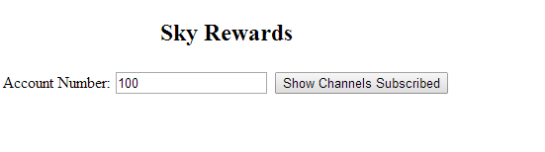
2. Click Show to view the list of rewards if eligible.

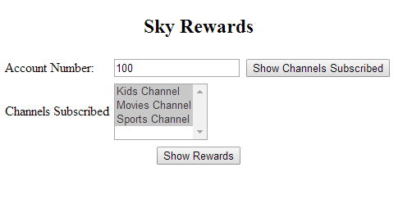

1. List of Rewards

